A LETTER FROM THE AUTHOR

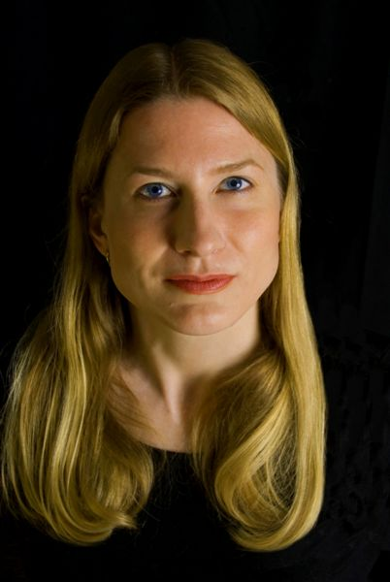
Dear Reader,

Like my main character, Marika, I entered my first war zone when I was twenty. I was backpacking alone around eastern and central Africa, attracted to places that were exotic and unfamiliar. I ended up in Madagascar, Malawi, Zambia—and Mozambique, during its civil war.

There are some moments in life that forever change who we are. My trip to Mozambique was one of them. I’d gotten a ride in a truck convoy that was passing down a notoriously dangerous road called the “Bone Yard Stretch”—so named for all the people who had been killed along the route. When the truck I was in broke down, some government troops found me and nearly gang-raped me. I had to run for my life over the border to Zimbabwe.

Such an experience might have turned others off to travel. Yet, as a woman, I’d found solo travel liberating and empowering—every day, it felt as if I were unearthing new strengths within me that I had never known existed. Not wanting to let that terrifying event in Mozambique stop me from following my passion, I started saving up money for a new trip—to Papua New Guinea, where most of my novel is set.

I went there alone, like Marika. I traversed its remotest jungles in a dugout canoe, or followed a native guide, hacking my way through the dim, tangled rain forest. I met indigenous people who were so isolated that they had never seen a white person, and I soon became intoxicated by the untouched beauty of the jungle and the uniqueness of tribal culture. My title in these remote areas was Wait Meri—White Mary—from the pidgin language introduced by Australian colonizers. Many people thought my blond hair was on fire. They believed I was a witch, and, terrified, would run off into the jungle at my approach.

As a reporter, I’ve always found myself drawn to especially dangerous places and situations: Bangladesh during a coup attempt, the jungles of Borneo, Rwanda shortly after the genocide. For one assignment, I went to Eastern Congo to cover the war, where I convinced some Ukrainian mercenaries to fly me to the epicenter of the violence. Marika’s African experiences are almost entirely based on my real-life experiences in the Congolese town of Bunia, which had been taken over by child soldiers. I saw thousands of refugees—mostly women and children—crowded into makeshift camps, the victims of heinous violence. I returned from that trip haunted by my inability to relieve the suffering of the people I had met. I ended up with post-traumatic stress disorder, and it took me years to recover from what I had seen.

In my novel, Marika ends up searching the jungles of Papua New Guinea for Robert Lewis, a famous war reporter who had supposedly committed suicide. As I wrote the book, I was obsessed with Lewis’s character—with the idea of someone who had let personal tragedy defeat him. After my brother died in Africa in 2005, my parents had allowed their own grief to destroy their lives. Not wanting the same thing to happen to me, I worked intensively with ayahuasca shamans in Peru, who, like my Tobo character in the novel, taught me about death and life, and passed on their wisdom and unique vision of the world. With their help, I healed from my brother’s death and from experiences like those I had in Congo, and I wanted to share my journey of overcoming through Marika. The White Mary is, more than anything, a story about hope.

Kira Salak

